Research Higher Degree Conceptual Diagram: Entitles, Relationships and Attributes.
Prepared by:
Thursdays Group 4
Sam Deane dean0109
Andrew Zschorn zsch0003

Version 1.0
10/4/2014

Created as part of the requirements for Advanced Database GE 2014
Contents
1. Identified entity types 2
1.1 Strong Entities 3
1.2 Associate Entities 3
2. Identify relationship types 4
3. Identify and associate attributes with entity or relationship types 4
3.1 Attributes by Entity 4
3.2 Attributes by Association Entity 7
4. Determined Domain attribute domains 8
5. Determined candidate, primary, and alternate key attributes 9
6. Use enhanced modelling concepts 10
7. Check model for errors and redundancy 10
8. Validate conceptual model against user transactions 11
9. Develop draft test plan 13
10. Review conceptual data model 13
11. Change Log 13
12. Other considerations and Decisions to be made 13

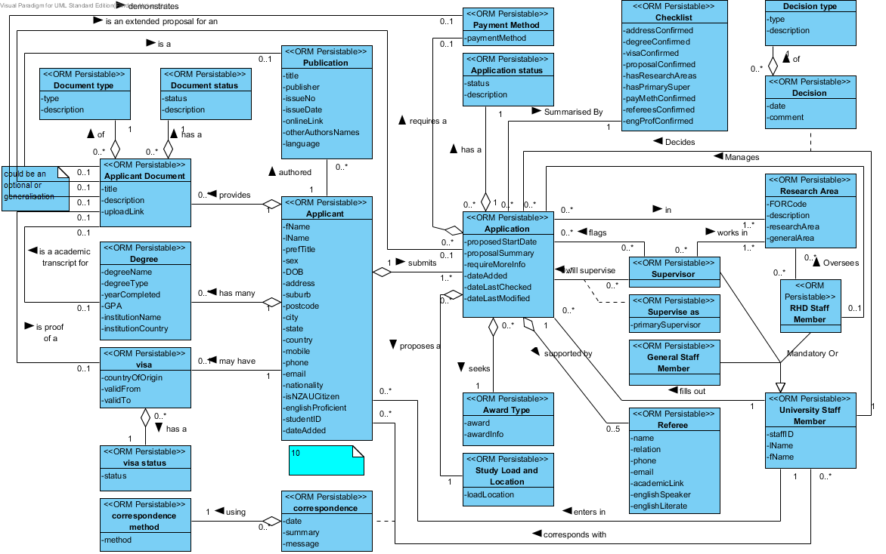

Identified entity types

Strong Entities
Entity Name | Aliases | Description | Occurrences (select multiplicities) | Entity #
Applicant | - | Holds the applicant specific details | Can be zero at the start but is expected to be many during use | 1
Applicant Document | - | Links to any relevant documents along with descriptions and types. | Zero or more for each applicant, specific to the Applicant. | 2
Application | - | Holds the application details | one or more for every Applicant | 3
Application status | - | A list of application status and who manages the application | a set number of predefined status reusable by all Applications | 4
Award Type | - | The Award sought by the Application | a set number of predefined Award types reusable by all Applications | 5
Checklist | - | Allows users to record the received and outstanding application information. | Always exactly one for each application. | 6
Correspondence Method | - | How the applicant and staff member corresponded | A set number of predefined correspondence methods reusable by all correspondences | 7
Decision Type | Change Type | The types of decisions a RHD Staff Member can make about an Application | A set number of predefined decisions types reusable by all decisions | 8
Degree | - | Any Degrees already held by the applicant | One or more for each applicant, specific to the Applicant. | 9
Document status | - | Official and translation status of a document associated to an Applicant | a set number of predefined documents status reusable by all Documents | 10
Document Type | - | The type of document | a set number of predefined document types reusable by all Documents | 11
General Staff Member | - | A non-supervisor non RHD staff member |  | 12
Payment Method | - | The proposed method of payment for the RHD | a set number of predefined payment methods reusable by all Applications | 13
Publication | - | Publications that the applicant has authored | Zero or more of their publications can be added for each Applicant | 14
Referee | - | A referee for the applicant | One or more for each Applicant | 15
Research area | - | The areas of a research an application or staff member is in. | a set number of predefined research areas, reusable by Staff and Applicants | 16
RHD Staff Member | - | A person who manages Applications and possible Supervisors | Can be zero to many depends on if the RHD staff will use the system to say how their managing Applications | 17
Study Load and Location | - | The proposed study load for the RHD and the location of the RHD | a set number of predefined study loads and locations reusable by all Applications | 18
Supervisor | CSEM  academic staff member | A person who can supervise a RHD applicant and project. | One for each academic staff member who uses the system or can be specified as a proposed supervisor by an Application | 19
University Staff Member | - | Supervisor or RHD Staff Member | Includes both of the above | 20
Visa | - | The applicants visa details | Zero or one for each Applicant (as required) | 21
Visa status | - | The applicants visa status | a set number of predefined visa status reusable by all Visas | 22

Associate Entities
Entity Name | Aliases | Description | Occurrences (select multiplicities) | Entity #
Correspondence | - | Correspondence between the Applicant and University Staff Member | Zero or more for every application | 23
Decision | Change Log | The decision and comment made for an application by a RHD staff member | Zero or more for every application | 24
Supervise as | Supervisor type | Supervise as a primary or secondary supervisor | One for ever supervisor | 25

Identify relationship types
Entity Name 1 | multiplicity | Relationship Name | multiplicity | Entity Name | Rel#
Applicant | 1 | provides | 0..* | Applicant Document | 1.1
Applicant | 1 | Submits | 1..* | Application | 1.2
Applicant | 1 | holds | 1..* | Degree | 1.3
Applicant | 1 | has authored | 0..* | Publication | 1.4
Applicant | 1 | May Require | 0..1 | Visa | 1.5
Applicant Document | 0..* | Has a | 1 | Document status | 2.1
Applicant Document | 0..* | of | 1 | Document type | 2.2
Applicant Document | 0..1 | is an extended proposal for an | 0..1 | Application | 2.3
Applicant Document | 0..1 | Is an academic transcript for | 0..1 | Degree | 2.4
Applicant Document | 0..1 | Is proof of | 0..1 | Visa | 2.5
Applicant Document | 0..1 | Is a | 0..1 | Publication | 2.6
Application | 0..* | Has a | 1 | Application Status | 3.1
Application | 0..* | In | 1..* | Research Area | 3.2
Application | 0..* | Prefers | 1..3 | Supervisor | 3.3
Application | 0..* | Proposes a | 1 | Study Load and Location | 3.4
Application | 0..* | Requires a | 0..1 | Payment Method | 3.5
Application | 1 | Summarized By | 1 | Checklist | 3.6
Correspondence | 1 | Supported By | 0..5 | Referee | 7.1
Correspondence | 0..* | seeks | 1 | Award | 7.2
Correspondence | 0..* | using | 1 | Correspondence Method | 7.3
RHD Staff Member | 1 | Decides | 0..* | Application | 17.1
RHD Staff Member | 0..* | Oversees | 0..* | Research Area | 17.2
RHD Staff Member | 1 | Manages | 0..* | Application | 17.3
Supervisor | 0..* | Flags | 0..* | Application | 19.1
Supervisor | 0..* | Will supervise | 0..* | Application | 19.2
Supervisor | 0..* | Works in | 1..* | Research Area | 19.3
University Staff Member | 0..* | Corresponds with | 0..* | Applicant | 20.1
University Staff Member | 1 | enters in | 0..* | Applicant | 20.2
University Staff Member | 1 | Fills out | 0..* | Application | 20.3
Visa | 0..* | Has a | 1 | Visa Status | 21.1

Identify and associate attributes with entity or relationship types

Attributes by Entity
Entity Name | Attribute Name | Description | Data type and Length* | Allow nulls | Multi -valued | attri#
Applicant | fName | First name | VARCHAR(50) | N | N | 1.1
Applicant | lName | Last name | VARCHAR(50) | Y | N | 1.2
Applicant | prefTitle | Title Mr, Mrs, Miss, Dr. * | CHAR(10) | Y | N | 1.3
Applicant | Sex | The sex of the applicant | TINYINT(1) | N | N | 1.13
Applicant | DOB | Date of birth | DATETIME | N | N | 1.4
Applicant | Address | Residence number and street of residence | VARCHAR(254) | N | Y | 1.5
Applicant | suburb | The suburb of residence | VARCHAR(100) | N | N | 1.6
Applicant | Postcode | The postcode of residence | MEDIUMINT | Y | N | 1.7
Applicant | City | The city or town of residence | VARCHAR(50) | Y | N | 1.8
Applicant | State | The State of residence | VARCHAR(50) | Y | N | 1.9
Applicant | country | The country of residence | CHAR(2)** | N | N | 1.10
Applicant | mobile | Mobile phone number | VARCHAR (50) | Y | N | 1.11
Applicant | Phone | Landline phone number | VARCHAR (50) | Y | N | 1.12
Applicant | email | The email address of the applicant | VARCHAR(100) | N | N | 1.14
Applicant | nationality | The nationality of the applicant | CHAR(2)** | N | N | 1.15
Applicant | isNZAUCitizen | Is a new Zealand or Australian citizen – a check to see if visa information is required *** | TINYINT(1) | N | N | 1.16
Applicant | englishProficient | English ability | TINYINT | N | N | 1.17
Applicant | studentID | The flinders university student id if they are or have been enrolled at flinders university | UNSIGNED MEDIUMINT | Y | N | 1.18
Applicant | dateAdded | The date the applicant was added to the system | DATETIME | N | N | 1.19
Applicant Document^ | Title | The title of the document | VARCHAR(254) | N | N | 2.1
Applicant Document^ | Description | A specific summary related to the document i.e. valid till 2015 etc. | VARCHAR(2000) | Y | N | 2.2
Applicant Document^ | uploadLink | An link to a version uploaded and stored on the university servers | VARCHAR(254) | N | N | 2.3
Application | proposedStartDate | The date the applicant prefers to start the RHD (Entered as 1/1/## for S1 and 1/7/## for S2) | DATETIME | N | N | 3.1
Application | proposalSummary | What the proposal is about | VARCHAR(2000) | N | N | 3.2
Application | requireMoreInfo | Application will run through the checklist and if information is missing will mark as false | TINYINT(1) | N | N | 3.3
Application | dateAdded | The date the application was submitted/saved | DATETIME | N | N | 3.4
Application | dateLastChecked | The date the application was last checked | DATETIME | N | N | 3.5
Application | dateLastModified | the date the application was last modified | DATETIME | N | N | 3.6
Application status | status | The name of an application status | VARCHAR(50) | N | N | 4.1
Application status | description | What the status means | VARCHAR(500) | N | N | 4.2
Award Type | award | An award name | VARCHAR(50) | N | N | 5.1
Award Type | awardInfo | General information about the award plus requirements | VARCHAR(2000) | Y | N | 5.2
Checklist | addressConfirmed | All contact details appear valid | TINYINT(1) | N | N | 6.1
Checklist | degreeConfirmed | The degree is a recognised degree of the institution | TINYINT(1) | N | N | 6.2
Checklist | visaConfirmed | The visa status is backed by an official document | TINYINT(1) | N | N | 6.3
Checklist | proposalConfirmed | The proposal is contains appropriate detail | TINYINT(1) | N | N | 6.4
Checklist | engProfConfirmed | The applicant has some level of English literacy | TINYINT(1) | N | N | 6.5
Checklist | hasResearchAreas | Has nominated research areas relevant to the proposal | TINYINT(1) | N | N | 6.6
Checklist | hasPrimarySuper | Has the required number of supervisors | TINYINT(1) | N | N | 6.7
Checklist | payMethConfirmed | The payment method is backed by an official document | TINYINT(1) | N | N | 6.8
Checklist | refereesConfirmed | The referees details appear to be correct | TINYINT(1) | N | N | 6.9
Correspondence Method | method | Correspondence method; phone email etc. | VARCHAR(50) | N | N | 7.1
Decision Type | type | the name of the decision type | VARCHAR(50) | N | N | 8.1
Decision Type | description | A description of the decision type | VARCHAR(500) | Y | N | 8.2
Degree | degreeName | The title of the degree | VARCHAR(100) | N | N | 9.1
Degree | degreeType | The type of the degree - Could add specific types | VARCHAR(100) | N | N | 9.2
Degree | yearCompleted | The year the degree was completed or will be completed | DATETIME | N | N | 9.3
Degree | GPA | The GPA of the degree | VARCHAR(5) | N | N | 9.4
Degree | institutionName | The name of the institution | VARCHAR(100) | N | N | 9.5
Degree | institutionCountry | The country the institution is located in | CHAR(2)** | N | N | 9.6
Document status | status | The name of an document status | VARCHAR(50) | N | N | 10.1
Document type | type | The name of a document type | VARCHAR(50) | N | N | 11.1
General Staff Member | - | - | - | - | - | 12
Payment Method | paymentMethod | The name of a payment method | VARCHAR(50) | N | N | 13.1
Publication | Title | The title of the publication | VARCHAR(254) | N | N | 14.1
Publication | abstract | A abstract/description of the publication | VARCHAR(2000) | Y | N | 14.2
Publication | publisher | The journal/magazine publisher | VARCHAR(254 | N | Y | 14.3
Publication | issueNo | The issue/edition number of the publication | MEDIUMINT | Y | N | 14.4
Publication | issueDate | The date the publication was issued | DATETIME | N | N | 14.5
Publication | onlineLink | An online link to the publication | VARCHAR(254) | Y | N | 14.6
Publication | otherAuthorsNames | Other authors of the publication | VARCHAR(254) | N | Y | 14.7
Publication | language | language of the publication | VARCHAR(50) | N | N | 14.8
Referee | name | The full name of the referee | VARCHAR(100) | N | N | 15.1
Referee | relation | The referees relation to the applicant | VARCHAR(100) | N | N | 15.2
Referee | phone | The referees phone number | VARCHAR(50) | Y | N | 15.3
Referee | email | The referees email address | VARCHAR(100) | N | N | 15.4
Referee | academicLink | The referees professional page (linked in or university) | VARCHAR(254) | N | N | 15.5
Referee | englishSpeaker | If the Referee can speak English | TINYINT(1) | Y | N | 15.6
Referee | englishLiterate | If the Referee can read and write in English | TINYINT(1) | Y | N | 15.7
Research Area | FORCode | The Australian Field Of Research (FOR) code | SMALLINT | N | N | 16.1
Research Area | Description | A small text description of the FOR i.e. 2201 | VARCHAR(2000) | N | N | 16.2
Research Area | researchArea | The FOR title; i.e. Applied Ethics | VARCHAR(50) | N | N | 16.3
Research Area | generalArea | The general area of the FOR | VARCHAR(50) | N | N | 16.4
RHD Staff Member | - | - | - | - | - | 17
Study Load and Location | loadLocation | A load and the location | VARCHAR(50) | N | N | 18.1
Supervisor | - | - | - | - | - | 19
University Staff Member | staffID | The flinders uni staff id number | MEDIUMINT | N | N | 20.1
University Staff Member | fName | The first name of the staff member | VARCHAR(50) | N | N | 20.2
University Staff Member | lName | The last name of the staff member | VARCHAR(50) | N | N | 20.3
Visa | validFrom | When the visa is valid from | DATETIME | Y | N | 21.1
Visa | validTo | When the visa is valid to | DATETIME | Y | N | 21.2
Visa Status | status | Approved unapproved, submitted, waiting etc. | VARCHAR(50) | N | N | 22.1

Attributes by Association Entity
Entity Name | Attribute Name | Description | Data type and Length* | Allow nulls | Multi -valued | attri#
Correspondence | date | The date the correspondence was made/received | DATETIME | N | N | 23.1
Correspondence | summary | A small summary of the Correspondence | VARCHAR(1000) | Y | N | 23.2
Correspondence | message | The actual message contained in the correspondence | VARCHAR(1000) | N | N | 23.3
Decision | date | The date the decision was made on | DATETIME | N | N | 24.1
Decision | comment | Extra information about the decision | VARCHAR(1000) | Y | N | 24.2
Supervise as^^^ | primarySupervisor | True will supervise as primary supervisor else as a secondary supervisor | TINYINT(1) | N | N | 25.1

Related information
* types not specifically set
** uses the ISO 3166-1 alpha-2 code
*** as per the Australian High Commission New Zealand - http://www.newzealand.embassy.gov.au/wltn/study.html
^ a degree, publication, visa or other document may include
^^ primary supervisors are decided on a first come first serve basis

Field lengths are based on the approximation that 500 chars is approximately 100 words
2000~400 words

Determined Domain attribute domains
Entity Name | Attribute Name | Domain (includes validation information) | Default value | attri#
Applicant | prefTitle | - | - | 1.3
Applicant | DOB | >16 years old | - | 1.4
Applicant | country | ISO 3166-1 alpha-2 code | - | 1.10
Applicant | Sex | Male/Female | - | 1.13
Applicant | email | Is a valid Email address | - | 1.14
Applicant | Nationality | ISO 3166-1 alpha-2 code | - | 1.15
Applicant | isNZAUCitizen | y/n | - | 1.16
Applicant | englishProficient | (~0-120) TOEFL Score | - | 1.17
Applicant | studentID | >1,000,000 and <2,500,000 | - | 1.18
Applicant | dateAdded | Is a date | CURDATE() | 1.19
Applicant Document | uploadLink | Is a URL | - | 2.3
Application | proposedStartDate | > CURDATE() and CURDATE()+5years< | - | 3.1
Application | previousRHDOfficer | Id | - | 3.2
Application | awaitingInformation | y/n | y | 3.3
Application | dateAdded | - | CURDATE() | 3.4
Application | dateChecked | - | - | 3.5
Application | dateLastModified | Always CURDATE on Application or its relationships change | CURDATE() | 3.6
Application status | status | - Rejected – application is rejected  - not eligible – applicant is found to be unable to apply  - Unfinished – the application still requires information/unfinished  - Proposed – the application is finished and proposed  - Flagged – staff have flagged as interested  - Partially assigned – some staff have agreed to supervise  - Assigned – staff have agreed to supervise  - Formal pending – all details are in order, formal process starts  - Approved – formal application is approved | - | 4.1
Application status | Description | – of the above | - | 4.2
Award Type | award | - Master of Arts  - Master of Biotechnology  - Master of Business  - Master of Clinical Education  - Master of Clinical Rehabilitation  - Master of Engineering  - Master of Laws  - Master of Science  - Master of Surgery  - Master of Theology  - Doctor of Philosophy (PhD) in all disciplines  - Doctor of Philosophy (Clinical Psychology) – includes some coursework.  - Doctor of Education  - Doctor of Public Health  Cotutelle Doctorate – (Flinders University and an international higher education institution) | - | 5.1
Award Type | awardInfo | – of above + other subclasses and admission info | - | 5.2
Correspondence Method | method | - Phone  - Email  - Skype  - Mail | Email | 6.1
Decision Type | Type | - Status change – Application status change (status to from added automatically by  - Info request – a request has been made for Information  - requested  - Application handed over to | - | 7.1
Decision Type | description | - More information on the decision type | - | 7.2
Degree | degreeType | - Certificate  - Associate Degrees  - Diploma  - Postgraduate diploma  - Bachelor Degree  - Bachelor(honours)  - Graduate Diploma  - Graduate Certificate  - Masters  - Graduate Entry Masters  - Professional Masters  - PHD | - | 8.2
Degree | yearCompleted | >CURDATE-2YEARS | - | 8.3
Degree | GPA | >0 and <10 | - | 8.4
Degree | institutionCountry | ISO 3166-1 alpha-2 code | - | 8.6
Document status | status | - Official  - Unofficial  - Official translation  - Unofficial translation  - N/A | N/A | 9.1
Document type | type | - Paper  - Academic transcript  - Proposal  - Proof of financial ability  - Visa application acceptation paper  - other | - | 10.1
Checklist | addressConfirmed | Y/N | N
Checklist | degreeConfirmed | Y/N | N
Checklist | visaConfirmed | Y/N | N
Checklist | proposalConfirmed | Y/N | N
Checklist | engProfConfirmed | Y/N | N
Checklist | hasResearchAreas | Y/N | N
Checklist | hasPrimarySuper | Y/N | N
Checklist | payMethConfirmed | Y/N | N
Checklist | refereesConfirmed | Y/N | N
Payment Method | paymentMethod | - student loan  - savings  - government assistance (AU)  - government assistance (Foreign government)  - scholarship | - | 12.1
Publication | issueNo | - | - | 13.4
Publication | issueDate | - | - | 13.5
Publication | onlineLink | isURL | - | 13.6
Referee | phone | isPhone | - | 14.3
Referee | email | isEmail | - | 14.4
Referee | academicLink | Is html page | - | 14.5
Referee | englishSpeaker | Y/N | - | 14.6
Referee | englishLiterate | Y/N | - | 14.7
Research Area | FORCode | FORCode | - | 15.1
Research Area | Description | - | - | 15.2
Research Area | researchArea | FORCode tilte | - | 15.3
Research Area | generalArea | - DIVISION 01 MATHEMATICAL SCIENCES  - DIVISION 04 EARTH SCIENCES  - DIVISION 05 ENVIRONMENTAL SCIENCES  - DIVISION 08 INFORMATION AND COMPUTING SCIENCES  - DIVISION 09 ENGINEERING  - DIVISION 10 TECHNOLOGY | -
Study Load and Location | loadLocation | - Internal Full Time  - Internal Part Time  - External Full Time  - Internal Full Time | 1 | 17.1
Visa | countryOfOrigin | ISO 3166-1 alpha-2 codes | - | 20.1
Visa Status | status | - student visa  - unknown | unknown | 21.1

- Not null no default
* Possible but will not be implemented

Determined candidate, primary, and alternate key attributes
Entity Name | Primary Key | Alternative Key | Entity#
Applicant | applicantID | fName & Phone FName & streetAddress fName & emailAddress | 1
Applicant Document | appDocID |  | 2
Application | applicationID | - | 3
Application status | appStatusID | Status, description | 4
Award Type | awardID | Award type | 5
Checklist | applicationID | - | 6
Correspondence Method | corrMethodID | Method | 7
Decision Type | decTypeID | Type, description | 8
Degree | degID | - | 9
Document status | docStatID | status, description | 10
Document Type | docTypeID | type, description | 11
Payment Method | methodID | method | 12
General Staff Member | staffID | - | 13
Publication | pubID | - | 14
Referee | refID | - | 15
Research area | FORCode | - | 16
RHD Staff Member | staffID | fName + Research Areas | 17
Study Load and Location | loadLocID | loadLocation | 18
Supervisor | staffID | - | 19
University Staff Member | staffID | - | 20
Visa | visaID | - | 21
Visa status | visaStatusID | status | 22

Supervisor, General Staff Member and RHD staff Member will all be merged into University Staff Member with a discriminated added to state the type as none of these specialised classes have any specific data type.

Use enhanced modelling concepts
We have used enhanced modelling concepts where appropriate.

University Staff Member generalises General Staff Member, Supervisor and RHD Staff Member. This relationship is marked as Mandatory Or, as every University Staff Member must be one of the specialised staff member groups, but these aren’t mutually exclusive groups, e.g. a Supervisor may also be a RHD Staff Member.

We have also used the aggregation relation where possible to show that all such relations have an “is-part-of” nature.

We investigated the use of generalisation relation from Application Document to Publication, Degree, Visa, Application or Payment Method. This approach was rejected as we found there were too many distinct attributes among the specialised entities.

Check model for errors and redundancy
- Re-examine one-to-one (1:1) relationships;
DONE
- Remove redundant relationships;
Applicant Provides Application left in to account for other documents
DONE
- Consider time dimension.
DONE
- Check for fan traps and chasm traps.
DONE

Validate conceptual model against user transactions
Identify transaction pathways and check that they will work.
The following user pathways were tested:

University Staff Members
# | pathway
 | Look up applicant + publications + degrees + visa Status + Associated documents by applicant name
 | Look up applicant’s applications by applicant name
 | Look up applicant’s applications by applicant email
 | Look up incomplete applications
 | Look up all correspondences relevant to the application
 | Insert Applicant
 | Who edited the Applicant/Application last
 | Create new applicant and associated application records
 | Look up an existing application and attach a new standard type document to an application
 | Look up an existing application and attached a new exceptional type document to an application
 | Look up an existing application and list outstanding information (checklist).
 | Elevate the certainty status flag of a piece of information relating to an existing application
 | Retrieve all on-going applications for which the user has made the most recent correspondence
 | Record making a decision about an application
 | Update the status of an application

Academic Staff
# | pathway
 | Look up, add to, and delete from own current research areas
 | Search for all applications in certain research areas that have been added since a certain time
 | Flag interest in an application

RHD Co-ordination Staff
# | pathway
 | Who edited the Applicant/Application last
 | Retrieve all ongoing applications

Note that going through transaction f) forced changes to the conceptual design; these are noted in the Change Log section 11 item a).
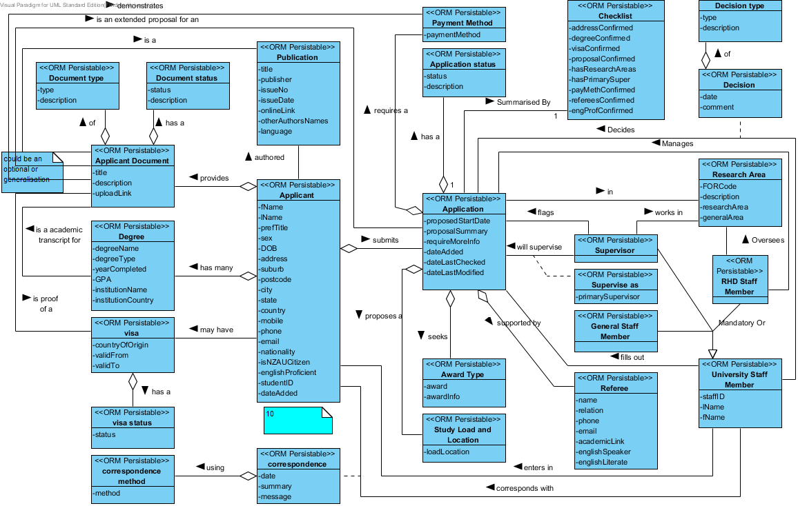
a
a
a
a, i, k, l
b, d, h
a
e, m
e, g
i, k
l
e, m
n
o, t
p
q
r
s
f
k

Develop draft test plan
We will generate a test data set to represent a baseline state of a running system. This includes a way to automatically load this baseline data into database system. This data set will need to be realistic, to ensure we are testing the system in a similar way in which it will be used. It will also have to be comprehensive to ensure that it tests integrity constraints.

We will also generate scripts that perform additional create, retrieve, update and delete operations that simulate a set of realistic user transactions, as listed in section 8. These scripts will include details of the expected result of each operation, to enable logging success/failure and time taken of each test.

As changes are made to the implementation of the system, we will compare the test logs before and after changes to ensure the system performance is improving overall.

As problems are discovered in the system implementation, ensure that the test suites are updated to include these newly discovered problems, to prevent reintroducing these errors.

We will evaluate for use the unit testing framework STK/Unit . If this product works as claimed, using it will simplify constructing and executing tests, and also evaluating the system performance against those tests, and tracking that performance over time.

Review conceptual data model
The conceptual model has been reviewed against the SRS, the original project description and reviewed by an end-user stakeholder (tutor). It was found that conceptual model presented here in will meet the data requirements of RHD admissions office.
The decisions made and new terminology in this document have been appended to the requirements specification.

Change Log
- Document type, Document Status, Application Status, Correspondence Method, Payment Method and Decision types all moved to separate entities of know finite tuples
- Application’s Fulltime and internal attributes combined and moved to Study Load and Location
- dateLastModifed and dateLastChecked added to application, these will also be updated in the application if an applicant is updated at the same time as requiresMoreInfo is checked
- fills out and enters in relationships added to University Staff Member
- Supervise as added moved supervise relationship.
- country added to Conceptual diagram but no added here

Other considerations and Decisions to be made
Question | affects
Does an applicant always say what research they want to do? | Submits application multiplicity
Is there a GPA conversion method available

Assumptions
- Applicant will always have enough information for an Application (proposal summary, start date, award they seek and load and location)
- The application will run the minimum submission checklist (not the checklist entity which is for user use only) after each update and: update the most recent applications; set requiresMoreInfo if more information is required; and update the dateLastModified.

Bibliography

